**PRACTICAL NO. 3**

**AIM:** To contribute to an open source play form by uploading files on GitHub.

**STEP 1:** On Github move to your main repository page and then we have to click on Upload Files.

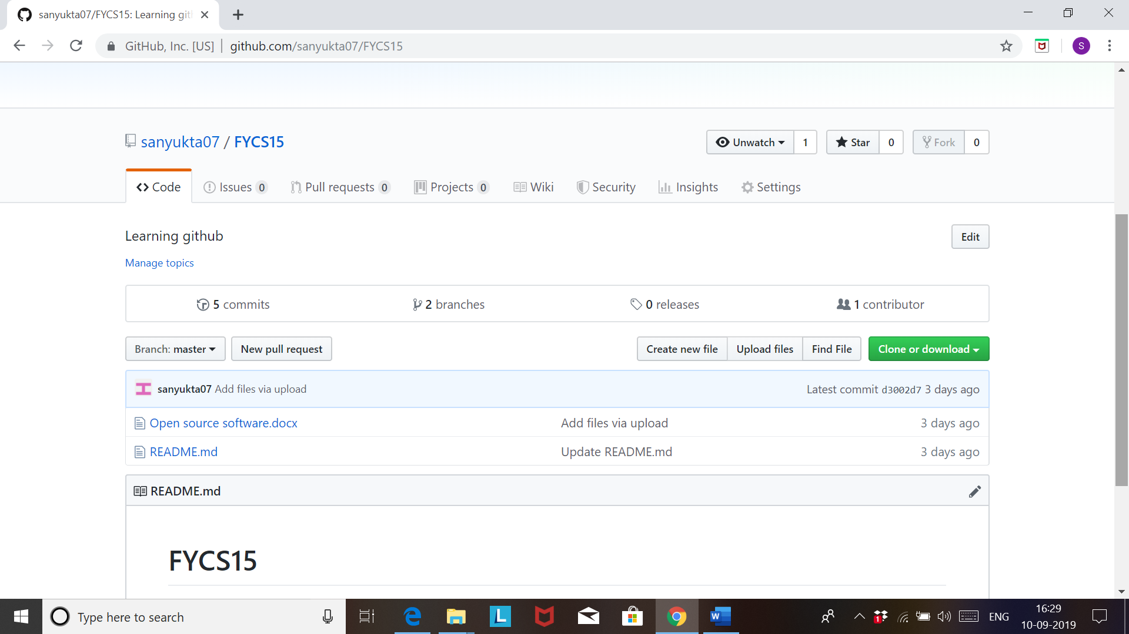

**STEP2**: A screen will appear where you can drop or choose any file of your choice. At the bottom of this page you will find a commit message box where you can type a short message regarding the file you have uploaded.

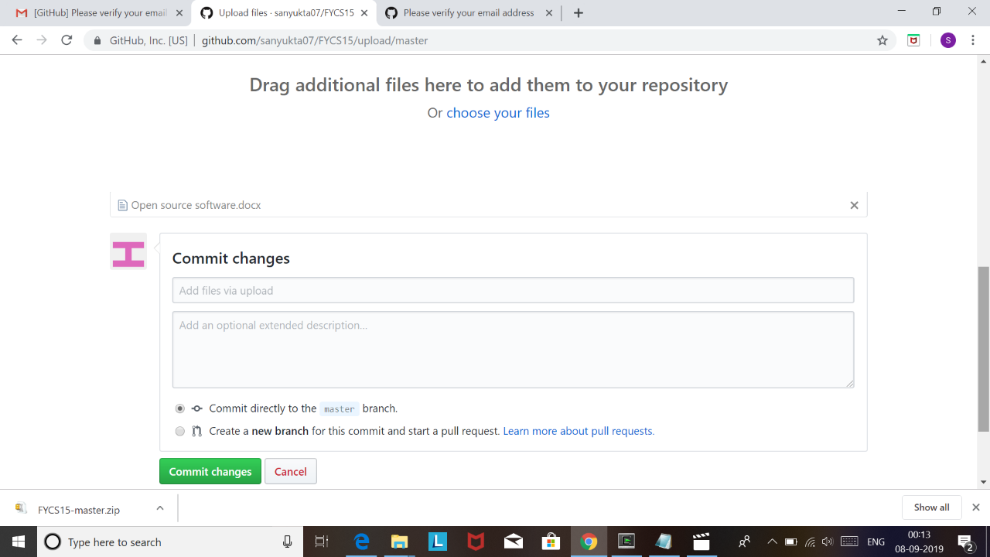

**STEP 3:** Now decide whether to add your commit to the current branch or to a new branch. If your current branch is master then you should choose for a new branch for your commit and click on the create a pull request. Click on commit changes.

